**VS CODE e-Project**

KITCHEN APPLIANCES

**group members:**

Abdalullah Sheikh

*Student*

*Ahmad Zafar  
Student*

*Ahsan Khan*

*Student*



# 

# KITCHEN APPLIANCES

**Table of Contents**

***ACKNOWLEGDMENT*** ***3***

***PROJECT CERTIFICATION*** ***4***

***INTRODUCTION TO KITCHEN APPLIANCES*** ***5***

***REQUIRMENT SPECIFICATION*** ***5***

***(A) HARDWARE REQUIRMENT*** ***5***

***(B) SOFTWARE REQUIRMENT*** ***5***

***SITE DEFINATION*** ***6***

***HOME PAGE (Detail)*** ***7***

***ABOUT US (Detail)*** ***8***

***PRODUT PAGE (Detail)*** ***6***

***CONTACT US (Detail)*****7**

# ACKNOWLEDGEMENT

***W***

*e are thankful to Almighty, ALLAH that by His grace we have been successful. we presenting on* ***VS CODE*** *in your hands. We have tried our best to take all relevant important topics in consideration so that this project may become comprehensive.*

*This is our* ***First Year Semester E****-project. We have tried our best & struggled for a better outlook to come. This project has been developed in* ***VS CODE.*** *We choose to make Webpage for* ***KITCHEN APPLIANCES*** *as a project. We find easy to do coding in* ***VS CODE.***

*We earnestly hope that this project will provide all the necessarily information required for the user to fulfill their inspiration. However suggestions for improvement of the project will be thankful received & acknowledge.*

**KITCHEN APPLIANCES**

**THANKING YOU……**

# KITCHEN APPLIANCES

# Project Certification



# “INTRODUCTION TO KITCHEN APPLIANCES”

*KITCEHN APPLIANCES is informative site which gives information about various mobiles products, Due to rapid development, the company decides to launch a website where people will get all the information about the various products available with them easily.*

**REQUIREMENT SPECIFICATION:**

*The Web site is to be created based on the following requirements.*

*1) The Home page must include images with slide show and links for navigation.*

*2) Proper template must be designed for the website, few section of the*

*webpage can be included to show or advertise the upcoming products.*

*3) Categories like Cookware, Refrigeration, Appliances, food storage, Knives and*

*tools, Laundry and other accessories*

*4) List such as:*

*- Cookware:*

*i. Cooking pots*

*ii. Cooking Pans*

*iii. Frying Pans*

*iv. Cookware Sets*

*v. Handis*

*vi. Kadais [Karahi]*

*vii. Grill pans*

*viii. Tawas*

*ix. Egg Poachers*

*x. Steamers*

*- Refrigeration*

*i. Freezers*

*ii. Refrigerators*

*- Appliances*

*i. Blenders*

*ii. Bread Makers*

*iii. Coffee Makers*

*iv. Ice-Cream and sorbet makers*

*v. Electric Kettles*

*vi. Food Choppers*

*vii. Toasters*

*- Food Storage*

*i. Flask*

*ii. Spice Jars*

*iii. Storage Bags*

*iv. Lunch Boxes*

*v. Vacuum bottles. And so on*

*5) Support Link can be added for proving aid services such as*

*- Manuals*

*- Expert Tips*

*- Register Complain*

*- Feedback*

*- Contact*

*6) Store Locators: must display the address location of all the branches*

*available.*

*7) Navigation of the project must be made precise and uniformity must be*

*maintained.*

**HARDWARE REQUIRMENT :**

* A minimum computer system that will help you access all the tools in the courses is a Pentium 166 or better
* *64 Megabytes of RAM or better*

**Software Requirements :**

* *Notepad/HTML editor*
* *Dreamweaver*
* *IE 5.0/ Netscape 6.0*

*DEVELOPER GUIDE :*

| **No.** | **Items** | ***Description*** |
| --- | --- | --- |
| 1 | Operating System | Window 98,2000,XP etc |
| 2 | Main processor | Minimum 166 or better |
| 3 | Ram (Memory) | Minimum 64 or better |
| 4 | Web Browser | Google Chrome/Firefox |
| 5 | Software | VS CODE/JavaScript/HTML Editor |

**System Requirement:**

*SITE MAP :*



















**HOME PAGE:**

**Home Page Is Available on all pages**

**You can add more image in slider**

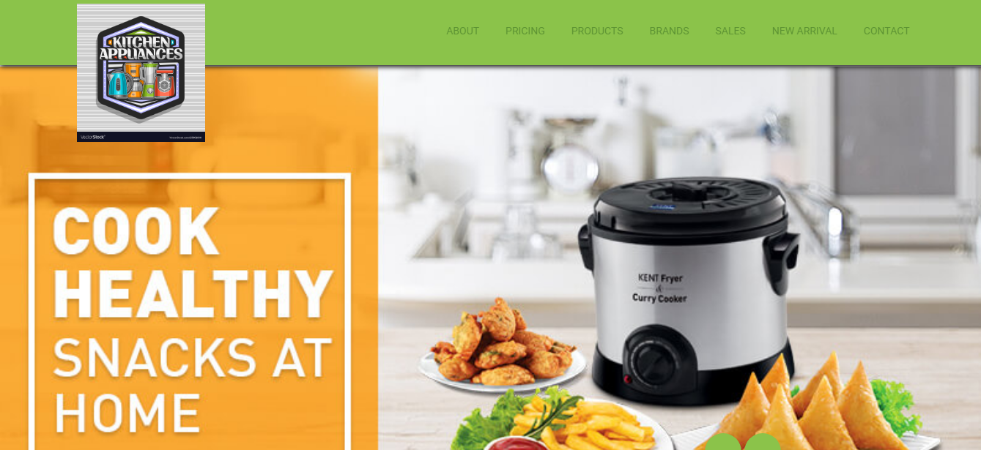

**.owl-carousel .owl-wrapper, .owl-carousel .owl-item:nth-child(1) .item**

**{**

**background: url('../images/c2.jpg');**

**background-size: cover;**

**background-position: bottom;**

**}**

**.owl-carousel .owl-wrapper, .owl-carousel .owl-item:nth-child(2) .item**

**{**

**background: url('../images/c1.jpg');**

**background-size: cover;**

**}**

**.owl-carousel .owl-wrapper, .owl-carousel .owl-item:nth-child(3) .item**

**{**

**background: url('../images/c3.jpg');**

**background-size: cover;**

**}Just Add This Lines**



**products:**

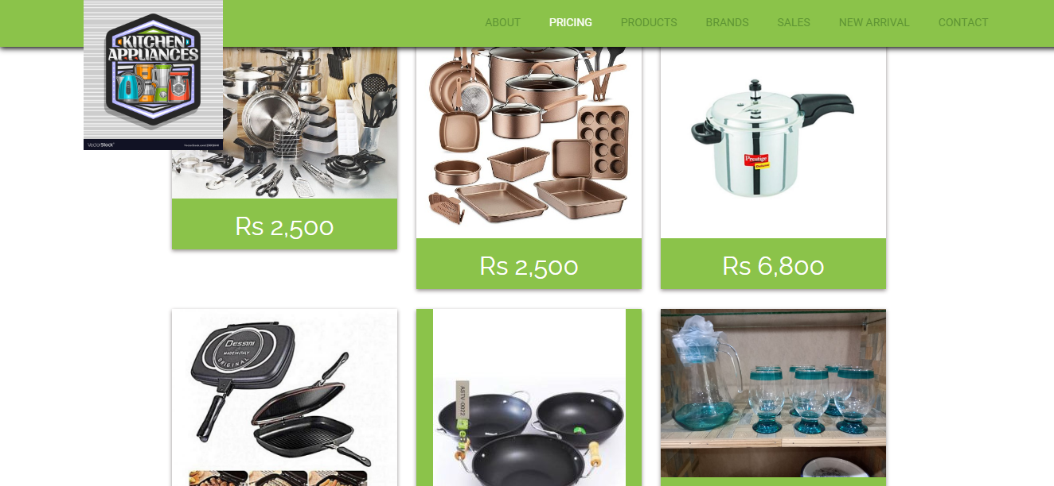



**you can add more products by**

<tr> <td width="68" align="center"><a href="your page name.html"><img src="img folder your img name.png" width="28" height="48"></a></td>

<td width="43">ing name</td></tabl

**contact us:**

